Brief User Manual for MUNIU Radar ROS2 Driver

Project Name | ROS2_MUNIU_RADAR
Document No.
Version | V1.0.1
Security Level
Author | Diao Tianping
Reviewer | Diao Tianping
Approver

All Rights Reserved Beijing MUNIU Leadership Technology Co., Ltd.
This document and all its contents are the property of Beijing MUNIU Leadership Technology Co., Ltd. (MUNIU Technology) and are protected by Chinese copyright laws and applicable international copyright conventions. Without the prior written authorization of MUNIU Technology, no one may copy, distribute, disseminate, modify or use part or all of the contents of this document in any form. Violators will be held legally responsible.
。

Document Update History
Date | Updater | Version | Description
2026.01.14 | DTP | V1.0.1 | Initial version completed

Table of Contents
Brief User Manual for MUNIU Radar ROS2 Driver 1
1、Overview 4
2、Environment Preparation 4
1). System Dependencies 4
2).Dependency Installation Commands 4
3). Workspace Preparation 5
3、Configuration File Modification 5
1) . CAN Protocol Radar (K77 as an Example) 5
2). UDP Protocol Radar (I79 as an Example) 6
4、Node Operation 7
1). Start Radar Node 7
2). Stop Radar Node 7
5、Data Verification 8
1). Topic Subscription Test Program 8
2). View Published Topic Data 8
3).View 3D Visualization 9
4. Topic Data Format 10
5. CAN Device Debugging (For CAN Protocol Radar) 14
6、Common Troubleshooting 15
7、Notes 16

1、Overview
Radar_muniu is a ROS2-based software library and toolset that enables radar sensors (via CAN bus) to stream object/target data into a 3D visualization environment for analysis, debugging, and integration into robotics or vehicle systems.

It currently supports three MUNIU radar models: I79, K77, and T79.

2、Environment Preparation

1). System Dependencies
• Operating System: Ubuntu 24.04 LTS
• ROS2 Version: Jazzy Jalisco
• Basic Dependencies: ROS2 Jazzy Desktop Edition, CAN-related tools, PCAN driver, YAML parsing library, network tools

2).Dependency Installation Commands
Install ROS2 Jazzy basic environment
sudo apt update && sudo apt install ros-jazzy-desktop
• Install CAN-related dependencies (for CAN protocol radar)
sudo apt install ros-jazzy-can-msgs ros-jazzy-socketcan-bridge
• Install YAML parsing and network-related dependencies
sudo apt install python3-yaml net-tools
• Install Boost library
sudo apt install -y libboost-all-dev
• Install Python and C++ environment
sudo apt install -y build-essential g++ python3-dev

3). Workspace Preparation
• Create and initialize ROS2 workspace
mkdir -p ~/radar_ws & cd ~/radar_ws
• Extract the radar_ros2_pkg.tar.bz2 compressed package
tar -xjvf radar_ros2_pkg.tar.bz2
cd ~/radar_ws/radar_ros2_pkg

3、Configuration File Modification
Configuration file path: install/radar_muniu/share/radar_muniu/config/radar_muniu_config.yaml. Modify the configuration according to radar hardware parameters:

. CAN Protocol Radar (K77 as an Example)

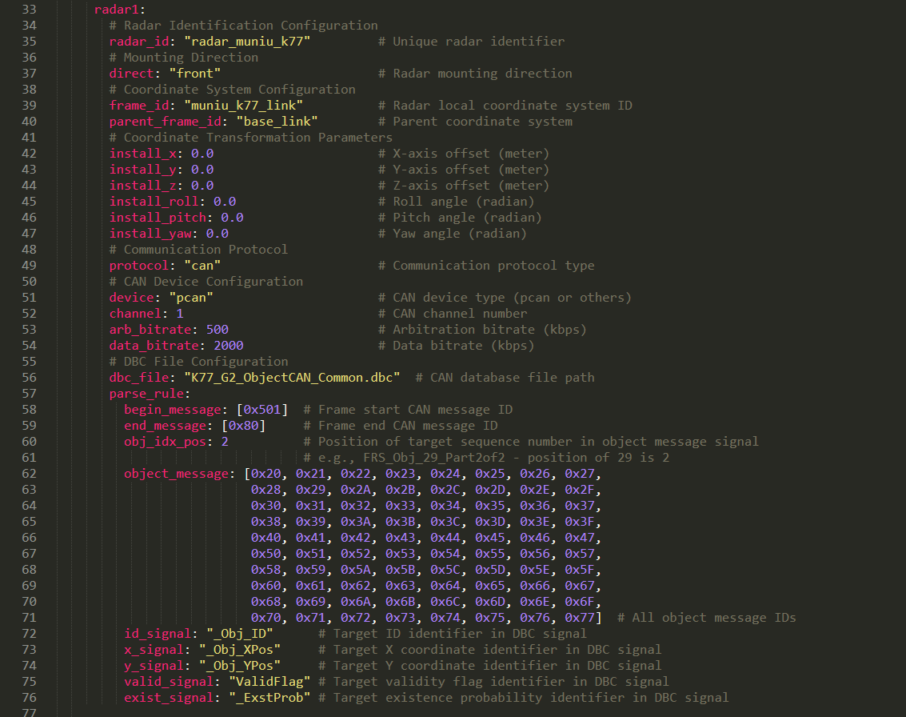

2). UDP Protocol Radar (I79 as an Example)
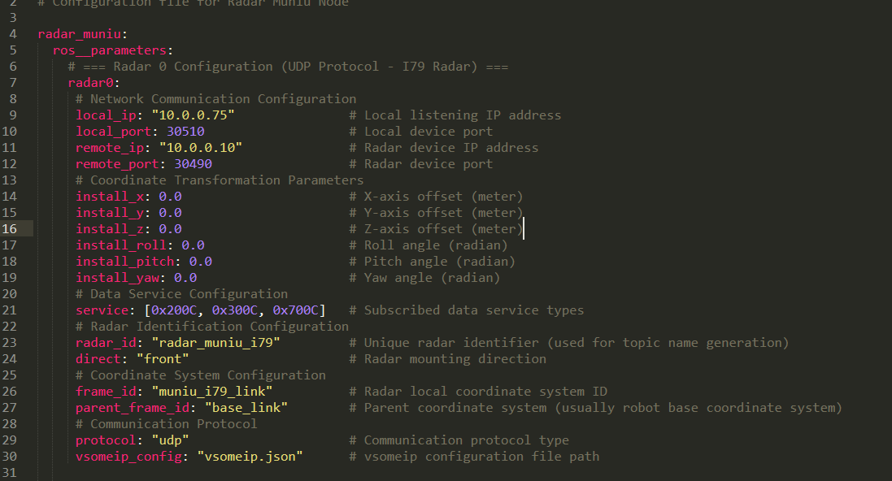

4、Node Operation

1). Start Radar Node
Start the radar node and RViz2 program via script
cd ~/radar_ws
./publish.sh
Note: publish.sh is started through the radar_launch.py file under the path install/radar_muniu/share/radar_muniu/launch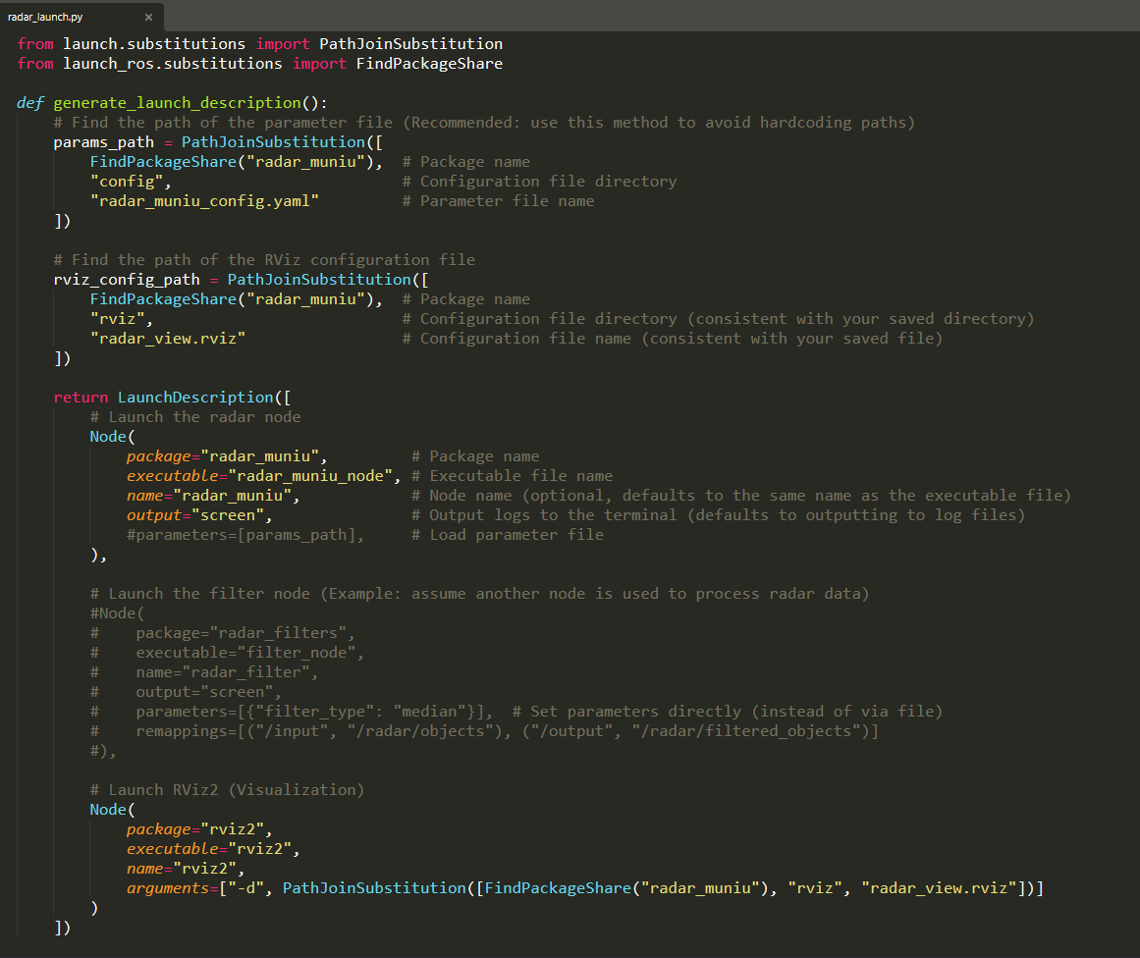

. Stop Radar Node
Use Ctrl + C to stop the node from running.

5、Data Verification

1). Topic Subscription Test Program
cd ~/radar_ws & ./subscriber.sh
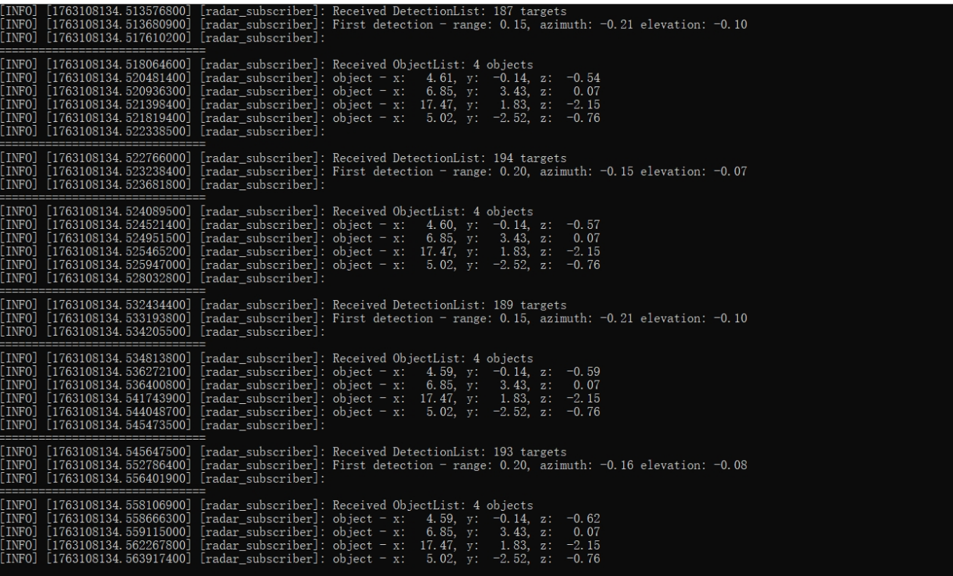

I79 Diagram

2). View Published Topic Data
ros2 topic list
The corresponding outputs for the three models are as follows:
K77:
/radar_muniu_k77/data/object_list（Target data topic）
/radar_muniu_k77/vis/object_list (RViz2 target topic)
I79:
/radar_muniu_i79/data/detection_list（Point cloud data topic）
/radar_muniu_i79/data/object_list(Target data topic)
/radar_muniu_i79/data/version_info (Version data topic)
/radar_muniu_i79/vis/object_list (RViz2 target topic)
/radar_muniu_i79/vis/detection_list(RViz2 point cloud topic)
T79：
/radar_muniu_t79/data/object_list(Target data topic)
/radar_muniu_t79/vis/t79_list(RViz2 point cloud topic)

3).View 3D Visualization
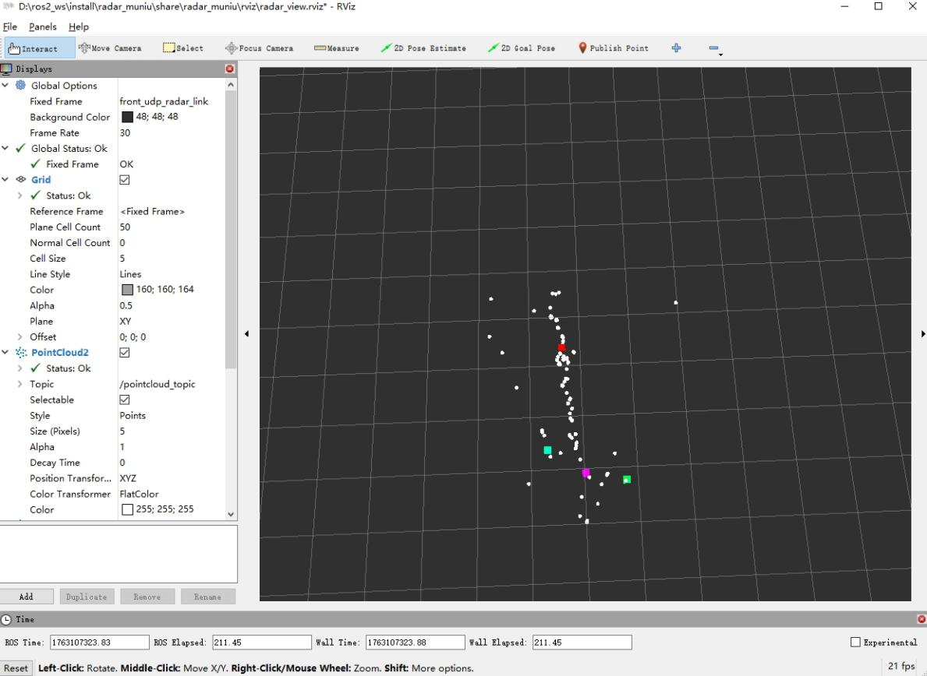
The local coordinate system IDs for the three radar models K77, I79, and T79 correspond to muniu_k77_link, muniu_i79_link, and muniu_t79_link respectively, which are generated according to the YAML file configuration.

4. Topic Data Format
1) I79
# detection
uint16 measurement_id
float32 azimuth_angle
float32 azimuth_angle_std
uint8 invalid_flags
float32 elevation_angle
float32 elevation_angle_std
float32 range
float32 range_std
float32 range_rate
float32 range_rate_std
int8 rcs
int8 snr
uint8 positive_predictive_value
uint8 classification
uint8 ambiguity_flag

#objecgt
uint32 object_id
uint16 object_age
uint8 object_status_measurement
uint8 object_status_movement
uint8 position_reference
float32 position_x
float32 position_x_std
float32 position_y
float32 position_y_std
float32 position_z
float32 position_z_std
float32 position_orientation
float32 position_orientation_std
float32 dynamics_vel_x
float32 dynamics_vel_x_std
float32 dynamics_vel_y
float32 dynamics_vel_y_std
float32 dynamics_vel_z
float32 dynamics_vel_z_std
float32 dynamics_acce_x
float32 dynamics_acce_x_std
float32 dynamics_acce_y
float32 dynamics_acce_y_std
float32 dynamics_acce_z
float32 dynamics_acce_z_std
float32 dynamics_orientation_rate
float32 dynamics_orientation_rate_std
float32 existence_prob
float32 obstacle_prob
uint8 classification
uint8 classification_prob
float32 shape_length_mean
float32 shape_length_std
float32 shape_width_mean
float32 shape_width_std
float32 shape_height_mean
float32 shape_height_std

#version
std_msgs/Header header
uint64 crc
uint32 length
uint32 sqc
uint32 data_id
uint32 frame_count
uint8[3] protocol_version
uint8[4] hw_pcb_ver
uint8[4] hw_bom_ver
uint8[4] cfg_version
uint8[4] sw_pl_ver
uint8[4] sw_ps_ver
uint8[3] alg_pt_ver
uint8[3] alg_trk_ver
uint8[3] calib_ver
uint8[16] sn_shell

2)K77 &T79
#DBC Message
std_msgs/Header header
uint32 id
string name
radar_msgs/DbcSignal[] signals

# DBC Signal
string name
float64 value
string unit

5. CAN Device Debugging (For CAN Protocol Radar)
1）Check CAN device status
ip link show can0 # If using SocketCAN
pcanview # If using PCAN device

- Monitor CAN bus data (verify if the radar sends messages)
candump can0 # SocketCAN
pcanfdump -f 500k -d 2000k /dev/pcan32 # PCAN (channel number must match)

6、Common Troubleshooting
Fault Phenomenon | Possible Causes | Solutions
CAN device not recognized | PCAN driver not installed successfully;  Mismatched channel number/baud rate;  3. Insufficient device permissions | 1. Execute ls /dev/pcan* to verify the driver and reinstall if necessary;  2. Check that the configuration file matches the hardware parameters;  3. Execute sudo chmod 777 /dev/pcan32 (adjust the path according to the actual situation)
No data from UDP radar | Local IP/port not connected to the radar's IP/port;  Radar not configured with data transmission target;  3. Firewall blocking | 1. Test connectivity with ping radar_IP;  2. Check radar network configuration;  3. Temporarily disable the firewall with sudo ufw disable for testing
No data output from topics | Verify the message IDs and signal names in parse_rule;  Validate the DBC file path and integrity;  3. Check if the install_* parameters are reasonable | 1. Verify the message IDs and signal names in parse_rule;  2. Validate the DBC file path and integrity;  3. Check if the install_* parameters are reasonable

7、Notes
• All configuration parameters (such as CAN baud rate, UDP port, DBC signal names) must be consistent with the radar hardware manual; otherwise, data parsing will fail.
• Before running the node, ensure the radar hardware is powered on and connected properly: the CAN bus termination resistor is normal, and the UDP radar is configured with a static IP and in the same network segment as the local IP.
• If ROS2 dependencies are missing under Ubuntu 24.04, they can be installed automatically with the following command:
rosdep install --from-paths src --ignore-src -r -y

